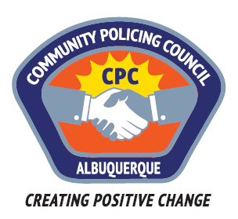

Valley Area Command Community Policing Council

AGENDA

May 25, 2017

APD Training Center
5412 Second St. NW
Albuquerque, NM

6:00pm Call to Order
Determination of a Quorum
Approve Agenda
Approve April 27, 2017, Meeting Minutes

6:15pm Guest speaker: Paul Haidle, ACLU presenting on APD Forward’s Analysis of the Independent Monitor’s
5th Report

7:15pm Guest speaker: Celina Espinoza, APD, Director of
Communications
Updates Monitors 5th report

8:00pm Meeting Adjourned

Next Meeting: June 22, “Panel on Immigration/Police Relationships”

